Social Media Posts
Images are available for download on the Connected, Not Controlled web page.
Students (For schools)
Do you know how digital tech can impact your mental health? 🤔 Too much screen time can lead to anxiety, depression, and low self-esteem. Let's talk about it! How do you balance your tech use? Find more digital tech facts at wechu.org/cnc | 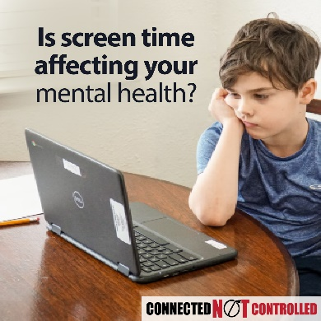
🚨 Digital Tech & Mental Health Alert! 🚨  Did you know that more screen time can mean more stress and anxiety? From increased anxiety and depression to multitasking, it's time to take control of our screen habits.  Remember: balance is key! What are your favorite ways to unplug?! Find more ideas at wechu.org/cnc | 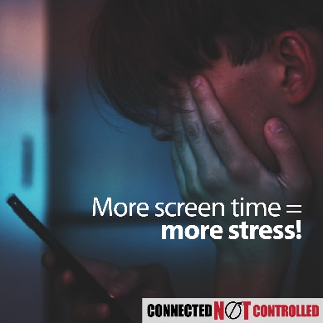
🌙💤 Are screens stealing your sleep? 😱 Many teens are spending over 5 hours a day on screens! That’s too much! Balance is the key! 🗝️ Aim for 8-10 hours of sleep and 60 minutes of fun physical activity daily. Remember, good sleep helps you shine during the day! ✨💪 Let's make healthier choices together! What’s your favorite way to stay active? Drop a comment! ⬇️  Find more tips at wechu.org/cnc | 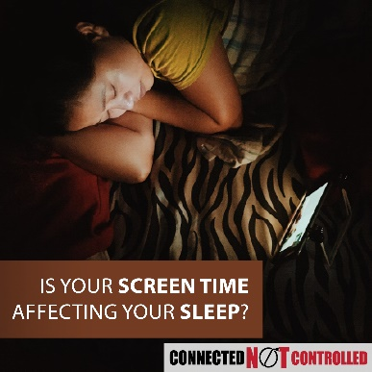
Feeling down after scrolling through social media? 😞 📱💕 Social media has pros and cons! On one hand, it helps us connect, especially for those who may feel alone. On the other, it can lead us comparing ourselves to peers and cyberbullying. 😔 Let’s choose kindness and support each other! Who’s your go-to person for support? Tag them below! 👇✨  Find more support at wechu.org/cnc | 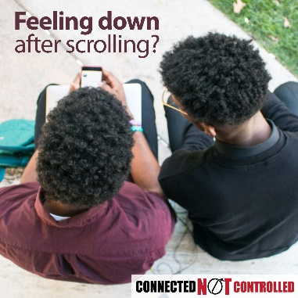
Are you spending too much time on screens? You're not alone!  It's time to take control! Here are some tips to balance screen time:  1️⃣ Set screen-free times and spaces. 📱  2️⃣ Set a time limit for gaming. 🎮  3️⃣ Turn off screens 1 hour before bed. 💤  Learn to use digital media wisely and be good digital citizens. How do you manage screen time? Share your tips! 👇💬  Find resources at wechu.org/cnc | 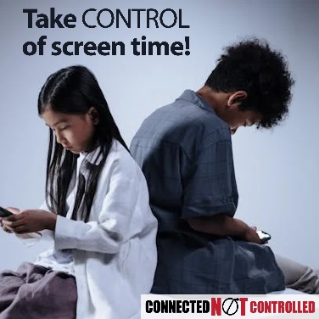

The following posts will be posted on WECHU accounts (in English) on the dates noted. Schools are encouraged to share/repost the content.
Challenge Promotions (For WECHU accounts and shared with the schools) | Post Date
📣 Hey #WEC youth! Get ready for the Connected, Not Controlled Challenge. The contest runs from April 14th to May 12th. Find more information at wechu.org/cnc  #ConnectedNotControlledChallenge | April 12
🚨 Calling All Students in grades 6 to 12! 🚨  Digital technology is everywhere, but how is it affecting your life? Join the #ConnectedNotControlledChallenge PSA Challenge! 🎥  📱 Create a 30-second video that includes a fact and a call to action.  🏆 Top videos & schools with the most participation win prizes!  📅 Submission period: April 14 - May 12, 2025.  Let’s take control of our screen time and promote positive digital habits!  📍 Learn more & submit here: wechu.org/cnc | April 14
🎬 It’s Time to Take Action! 🎬  Think about your daily screen time… 📱💻 Does it help or harm your mental well-being? It’s time to raise awareness & make a change!  Join the Connected, Not Controlled PSA Video Challenge by submitting a 30-second video that promotes positive tech habits. Your voice can make an impact! 💡  🏆 Awesome prizes for top videos & schools!  📅 Deadline: May 12, 2025  💡 Fact + Call to Action = Qualifying Video!  Let’s stay connected, not controlled. Are you in? 🚀 Tag a friend who should enter! 👇  #ConnectedNotControlledChallenge  📍 Learn more & submit here: wechu.org/cnc | April 28
Your voice matters! 🎤 📱 Create a 30-sec video on digital tech use and submit it to the #ConnectedNotControlledChallenge by May 12, 2025. 🏆 Prizes for top videos & schools! Let’s build healthier screen habits together!  Learn more at wechu.org/cnc | May 2
Screen time overload? Let’s talk about it! 🎬 Join the Connected, Not Controlled PSA Challenge by submitting a 30 video on the impact of technology on mental health.  Deadline: May 12! A chance to win prizes, raise awareness, and make a difference! | May 9
Check out these important #ConnectedNotControlledChallenge dates 📅 Help keep yourself organized by adding them to your calendar or saving this image.  Learn more at wechu.org/cnc | April 23
Time is almost up! Grade 6-12 students have one more week to submit the Connected, Not Challenge video ⏰  Don't miss out, visit wechu.org/cnc to learn more. | May 5
Thanks to all the students that submitted your videos. The Connected, Not Controlled Challenge had XXX submissions.  Videos are being reviewed, and the re-submission period is open. Videos that qualified will be voted on and narrowed down to the top 10 by youth judges.  Stay tuned public voting starts June 2nd! | May 14
Public voting is open now until June 9th!  📽️ Vote for your favourite Connected, Not Controlled Challenge video created by #WEC youth at wechu.org/cnc | June 9
Parent Focused (For WECHU accounts and shared with the schools)
Is screen time affecting your child’s mental health? 📱💔 Research shows that too much screen time can lead to anxiety, depression, and even self-harm. Let's talk about finding balance! How do you set screen time limits in your home?  Find more tips at www.wechu.org/cnc | April 16
🌟 Attention Parents! 🌟  Did you know that the more hours your youth spends on screens, the greater the risk of mental health issues like anxiety and depression? 😟 It's important to monitor their digital use!  🛌 Media multitasking affects sleep and focus, making schoolwork tougher. Teens are at risk of mental health challenges and cyberbullying.  Let's work together to create positive habits! How do you manage screen time in your family? Share your tips below! 👇  Find more tips at www.wechu.org/cnc | April 24
👨‍👩‍👧‍👦Parents, did you know that 82% of Windsor-Essex youth spend over 3 hours a day on screens? That's a lot of time that could be spent being active or sleeping! 💪📱  The 24-hour movement guidelines suggest:  • No more than 2 hours of recreational screen time daily  • 9 to 11 hours of sleep for ages 5-13 and 8 to 10 hours for ages 14-17  • At least 60 minutes of activity each day  Let's prioritize sleep and play! 💤🏃‍♀️  Encourage less screen time & more family fun! Find resources to balance screen time in your home: www.wechu.org/cnc | April 30
🌟 As parents, we want the best for our kids, especially in the digital world. Social media can help them connect, but it can also lead to negative feelings through cyberbullying and comparing themselves to peers. 😞 For some youth, online spaces can provide important support and friendship. Let's discuss how family and friends can model their tech use positively!  💬 How do you support your kids in navigating the digital world? Share your thoughts!  Find tips to talk to children and teens at: www.wechu.org/cnc | May 7
Is your family struggling with screen time? You're not alone!  It's time to take control! Here are some tips to balance screen time:  1️. Create a family media plan.  2️. Set screen-free times and spaces.  3️. Model healthy screen use.  Teach your kids to use digital media wisely and be good digital citizens. How do you manage screen time at home? Share your tips! 👇💬  Find resources at www.wechu.org/cnc | May 15

Announcements

Submission Period:
- Attention students! Are you ready to use your voice for change? The Connected, Not Controlled PSA Video Challenge is here! We want YOU to create a 30-second video about digital well-being and responsible tech use. The best videos will win prizes, and schools with the most participation will be recognized!
- Your video must include a fact about technology’s impact on health and well-being and a call to action.
- The deadline to submit is May 12, 2025.
- Let’s stay connected, not controlled! Visit wechu.org/cnc for more details.
- Have you heard about the Connected, Not Controlled Challenge? Windsor-Essex County students in grades 6 to 12 can create and upload a 30-second PSA video to raise awareness about the effects of digital technology use on their mental health and well-being. The video submission period runs from April 14th to May 12th. Enter your PSA video and you could win $300 and other cool prizes! Visit wechu.org/cnc for more information.
- Attention [name of school] students in grades 6 to 12! Are you ready to make a difference? Introducing the Connected, Not Controlled Challenge! Create a 30-second PSA video showcasing how digital technology can impact your mental health and well-being. From April 14th to May 12th, upload your video and compete for a chance to win $300 and awesome prizes! Get all the details at wechu.org/cnc and let your voice be heard!
- Time is running out, [name of school] students! Don’t miss your chance to enter the Connected, Not Controlled Challenge! Submit your 30-second PSA video about digital tech and mental health by May 12th for a shot at $300 and other awesome prizes! Visit wechu.org/cnc and get your entry in before it’s too late!

Voting Period:
- The Connected, Not Controlled Challenge submission period has closed. Starting June 2nd, you can vote daily for your favourite Connected, Not Controlled Challenge video. Visit wechu.org/cnc to vote.
- Have you been voting daily for your favourite Connected, Not Controlled Challenge video? Voting closes June 9th, visit wechu.org/cnc and vote today.

Assembly/ Student Council Pitch
- Attention students! Are you ready to use your voice to make a difference, get creative, and even win prizes? Introducing the Connected, Not Controlled PSA Video Challenge! This is your chance to use your voice and creativity to raise awareness about how digital technology impacts youth well-being and daily lives.
Here’s the challenge:
  - Create a 30-second PSA video that includes a fact about technology’s effects and a call to action.
  - Submit you video between April 14th – May 12th, 2025
  - Win prizes for the best videos AND help your school compete for the top participation award!
- Technology is everywhere, but are we connected, or controlled? Excessive screen time can affect mental health, sleep, relationships, and even school performance. It’s time to start the conversation! So make a plan, gather a few friends, and start filming! Visit wechu.org/cnc for all the details. Let’s create change—one video at a time!
- Have you heard about the Connected, Not Controlled Challenge? Windsor-Essex County students in grades 6 to 12 can create and upload a 30-second PSA video to raise awareness about how the use of digital technology can affect their well-being and daily lives. The video submission period runs from April 14th to May 12th. Enter your PSA video and you could win $300 and other cool prizes! Visit wechu.org/cnc for more information.
- Have you entered the Connected, Not Controlled Challenge? It’s not too late, Windsor-Essex County students in grades 6 to 12 can create and upload a 30-second PSA video to raise awareness about how the use of digital technology can affect their well-being and daily lives. The video submission period runs until May 12th. Enter your PSA video and you could win $300 and other cool prizes! Visit wechu.org/cnc for more information.
- Starting June 2nd, you can vote for your favourite Connected, Not Controlled Challenge Video. Voting closes June 9, visit wechu.org/cnc to vote.
- Have you voted for your favourite Connected, Not Controlled Challenge video yet? Voting closes June 12th, visit wechu.org/cnc to vote.

TV Image
Available for download on the Connected, Not Controlled web page.


Poster
Available for download on the Connected, Not Controlled web page.


